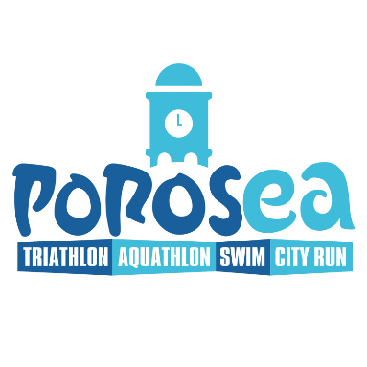
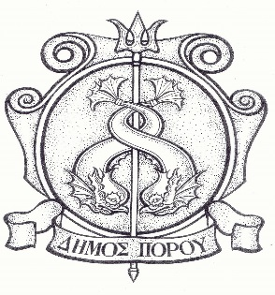
Poros, 12.4.2022

Announcement

Volunteer registration for Porosea 2022

Porosea is back once again this year on the weekend of 28 & 29 May 2022, revealing the beauty of Poros and the potential of the island in organizing large events.
The Municipality of Poros invites all residents (adults and children) who wish to contribute to this great celebration as volunteers, to send the details of the attached form by email to info@poros.gr or in hard cory to the Mayor's Office or to register by phone at 22983-20512 and 698 4221021.

